High Calls/Chats

14.1%: No Interactions

22.6%

43.4%

15.0%

4.9%

High Logins

Low Logins

**Dialing us Dave**

**Self-Service Susan**

**Infrequent Ian**

**Tailor to Me Tammy**

Low Calls/Chats

F/S:



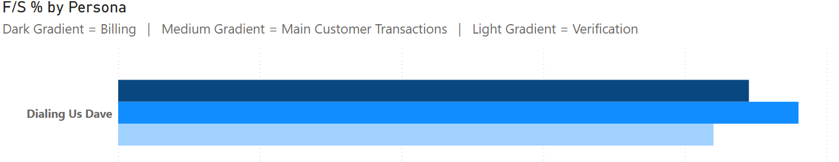

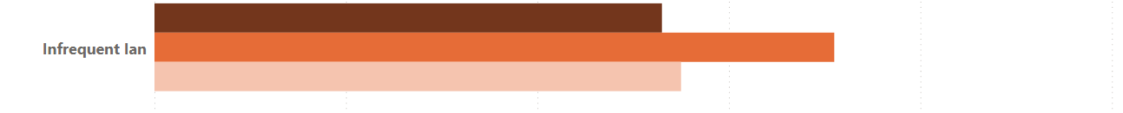

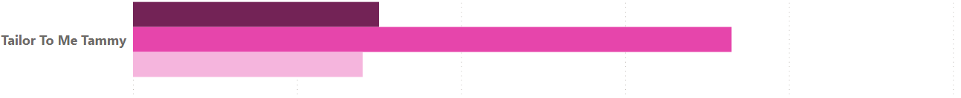

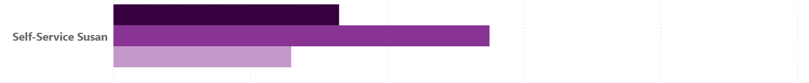



Usage Rate:



